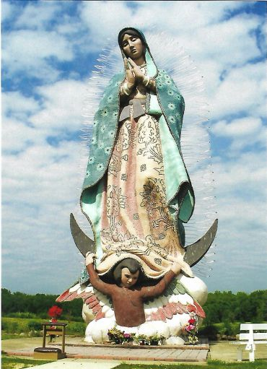
1st Annual
Pilgrimage

Franciscan Tertiaries
of the Immaculate Conception Province

Servants of Mary Center for Peace
Shrine of Our Lady of Guadalupe

Home of the world’s largest statue of Our Lady of Guadalupe

Date: Saturday May 21, 2022
Place: Servants of Mary Center for Peace & Shrine of Our Lady of Guadalupe
6601 Ireland Rd, Windsor, OH
Time: 10:30 AM to 2:00 PM

Mass Celebrant: Fr. Ryan Furlong, TOF

Lunch: Mary Yoder’s Amish Kitchen, Middlefield, OH

Carpooling sites:
- St. Nicholas Byzantine Church, Barberton (1 ½ hrs): departs at 8:30 AM
RSVP: Virgil Daniel, Tel: 440-292-6984
- Hartville Kitchen, Hartville (1 ½ hrs): departs at 8:30am
RSVP: Jim Miller, Tel: 330-353-0579
- Shrine of Our Lady Comforter of the Afflicted (1 hr): departs at 9:00 AM
RSVP: Pat Cuttica, TOF, Tel: 330-720-1546
- St. Joseph Catholic Church, Jefferson, OH (30 mins): departs 9:30 AM
RSVP: Julianne Pertz, TOF, Tel: 219-978-3373

What to bring: a rosary, lunch money (please contact your minister if the cost may be a burden), umbrella if needed, comfortable shoes and your Franciscan joy.

